1. C Program to Print an Integer entered by user.

Algorithm –

Step 1. Start.

Step 2. Declare variable a.

Step 3. Inputting the value of a.

Step 4. Print a.

Step 5. Stop.

Flowchart –

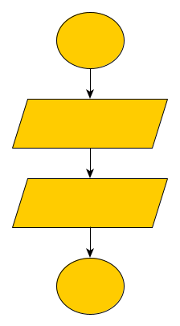

Start

Input a

Print a

Stop

Code –

#include <stdio.h>

int main()

{

int a;

printf("Enter Number ");

scanf("%d",&a);

printf("Enter Number is = %d",a);

}

Output –

Enter Number 9

Enter Number is = 9

2. C Program to add two numbers

Algorithm –

Step 1. Start.

Step 2. Declare variable a, b, sum.

Step 3. Inputting the values of a and b.

Step 4. Add a, b and assign the value to the sum.

Step 5. Print sum.

Step 6. Stop

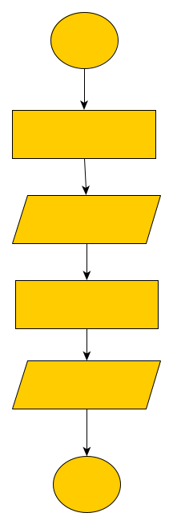Flowchart –

Start

Declare variable int a, b, sum=0

Input value of

a, b

sum = a+b

Print sum

Code –

Stop

#include <stdio.h>

int main()

{

int a,b; Output –

int sum=0;

printf("Enter Number 1\n"); Enter Number 1

scanf("%d", &a); 3

printf("Enter Number 2\n"); Enter Number 2

scanf("%d", &b); 7

sum=a+b; Sum is 10

printf("Sum is %d\n", sum);

}

3. C Program to multiply two numbers

Algorithm –

Step 1. Start

Step 2. Declare variable a, b, mul

Step 3. Inputting the values of a and b

Step 4. Multiply a, b and assign the value to the mul

Step 5. Print mul

Step 6. Stop

Flowchart – 

Start

Declare variable int a, b, mul=0

Read value of

a, b

sum = a*b

Print mul

Code –

Stop

#include <stdio.h>

int main()

{

int a,b; Output –

int mul;

printf("Enter Number 1\n"); Enter Number 1

scanf("%d", &a); 7

printf("Enter Number 2\n"); Enter Number 2

scanf("%d", &b); 5

mul=a*b; Multiple is 35

printf("Multiple is %d\n", mul);

}

4. C Program to calculate average of 5 given numbers.

Algorithm –

Step 1. Start

Step 2. Declare variable int total, n, avg.

Step 3. Initialize total = 0

Step 4. Using for loop to input value of n till n<5.

Add the value of n to the total.

Step 5. Divide the value of total by 5 and assign the value to avg.

Step 6. Print the value of avg.

Step 7. Stop.

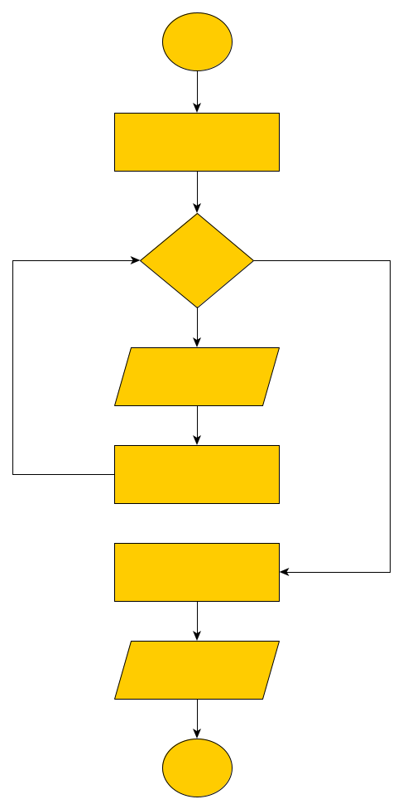Flowchart –

Start

Declare variable int n, avg, total=0

for(int i=0;

i<5; i++)

Input n

total = total +n

avg=total/5

Print avg

Stop

Code –

#include <stdio.h>

int main()

{

int total=0;

int n,avg;

printf("Enter 5 Number\n");

for(int i=0; i<5; i++)

{

scanf("%d", &n);

total+=n;

}

avg=total/5;

printf("Average=%d",avg);

}

Output –

Enter 5 Number

1

2

3

4

5

Average=3

5. C Program to print ASCII value of character

Algorithm –

Step 1. Start

Step 2. Declare character variable as chr

Step 3. Inputting the value of chr

Step 4. Print the value of chr using “%d” format specifier

Step 5. Stop.

Flowchart –

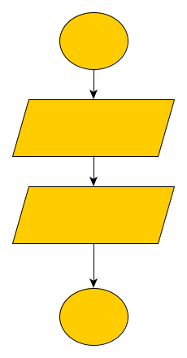

Start

Input chr

Print chr

Stop

Code –

#include <stdio.h> Output –

int main()

{ Enter character to find its ASCII value

char chr; E

printf("Enter character to find its ASCII value\n"); ASCII value is = 69

scanf("%c", &chr);

printf("ASCII value is = %d", chr);

}

6. C Program to print quotient and remainder if two integers are input by the user.

Algorithm –

Step 1. Start

Step 2. Declare variable n, d, q, rem.

Step 3. Initialize the value of q=0, rem=0.

Step 4. Inputting the value of n and d.

Step 4. if( d = = 0)

Print “Enter the value greater than zero”

Else

n will be divided by d and the value will be assigned to q (q = n/d)

rem will store the reminder (rem = n%d)

print the values of q and rem.

Step 5. Stop

Flowchart –

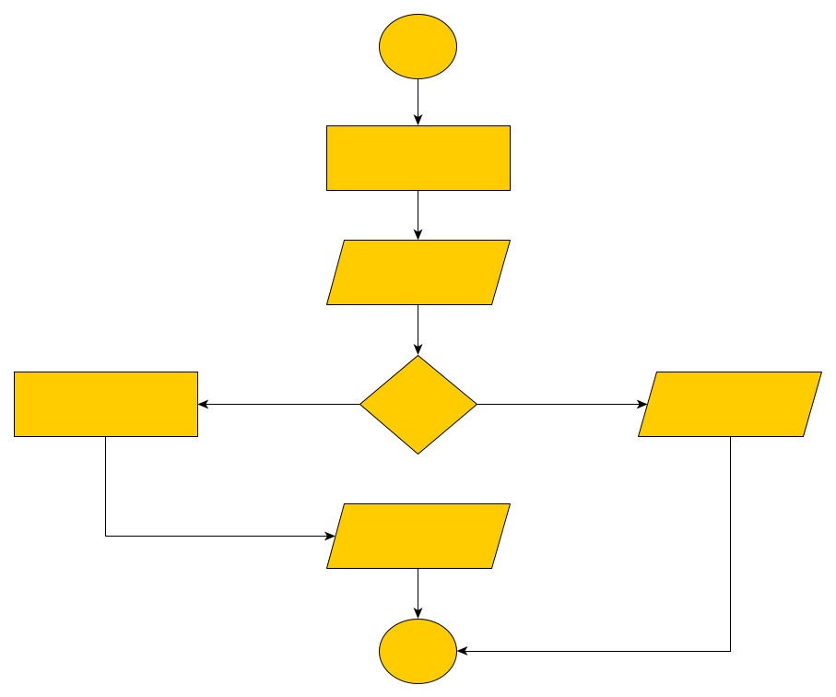

Start

Declare variable int n, d, q=0, rem=0

Input n, d

False

True

q= n/d

rem=n%d

Print “ Enter

greater value”

if(d= = 0)

Print q, rem

Stop

Code –

#include <stdio.h>

int main()

{

int n,d;

int q=0;

int rem=0;

printf("Enter First Number\n");

scanf("%d", &n);

printf("Enter Second Number\n");

scanf("%d", &d);

if(d==0)

{

printf("Enter value greater then ZERO\n");

}

else

{

q=n/d;

rem=n%d;

printf("Quotient = %d, Remainder = %d\n",q,rem);

}

Output –

Enter First Number

65

Enter Second Number

8

Quotient = 8, Remainder = 1

7. C Program to swap two numbers.

Algorithm –

Step 1. Start

Step 2. Declare the int variables a, b.

Step 3. Initialize the value of temp = 0

Step 4. Input the values of a, b from user and assign the values

Step 4. Assign temp = a

a = b

and b = temp

Step 5. Print the values of a and b

Step 6. Stop.

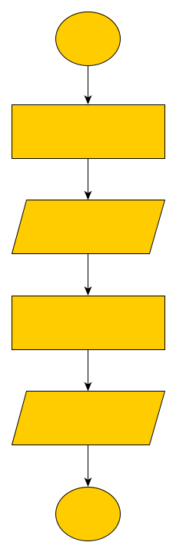Flowchart –

Start

Declare variable int a, b, temp=0

Input a, b

temp = a

a = b

b = temp

Print a, b

Stop

Code –

#include <stdio.h>

int main()

{

int a,b;

int temp=0;

printf("Enter First Number\n");

scanf("%d", &a);

printf("Enter Second Number\n");

scanf("%d", &b);

temp=a;

a=b;

b=temp;

printf("After Changing\n");

printf("First Number is %d and Second Number is %d", a,b);

}

Output –

Enter First Number

9

Enter Second Number

4

After Changing

First Number is 4 and Second Number is 9

8. C Program to check if number is odd or even

Algorithm –

Step 1. Start

Step 2. Declare integer variable n

Step 3. Inputting the value of n

Step 4. if n%2 == 0

Print "Entered number is even"

else

Print "Entered number is odd"

Step 5. Stop

Flowchart –

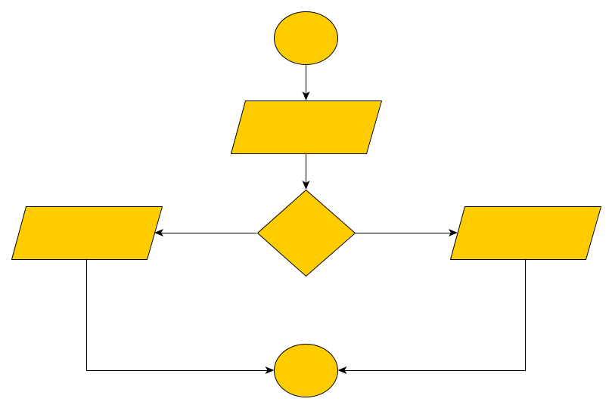

Stop

False

True

Print “Enter number

is odd”

Print “Enter number

is even”

if(n%2==0)

Input n

Start

Code –

#include <stdio.h>

int main()

{

int n;

printf("Enter Number\n");

scanf("%d", &n);

if(n%2==0)

{

printf("Number is even\n");

}

else

{

printf("Number is odd\n");

}

}

Output –

Enter Number

3

Number is odd

9. C Program to check if entered character is vowel or consonants

Algorithm –

Step 1. Start

Step 2. Declare the character variable ch and low

Step 3. Inputting the value of ch

Step 4. Convert the ch to lowercase (low=tolower(ch))

Step 5. if(low=='a' || low=='e'|| low=='i' || low=='o' || low=='u')

print "Entered character is vowel"

else if (low>='a' && low<='z')

print "Entered character is a consonant "

else

print “Invalid input”

Step 6. Stop

Flowchart –

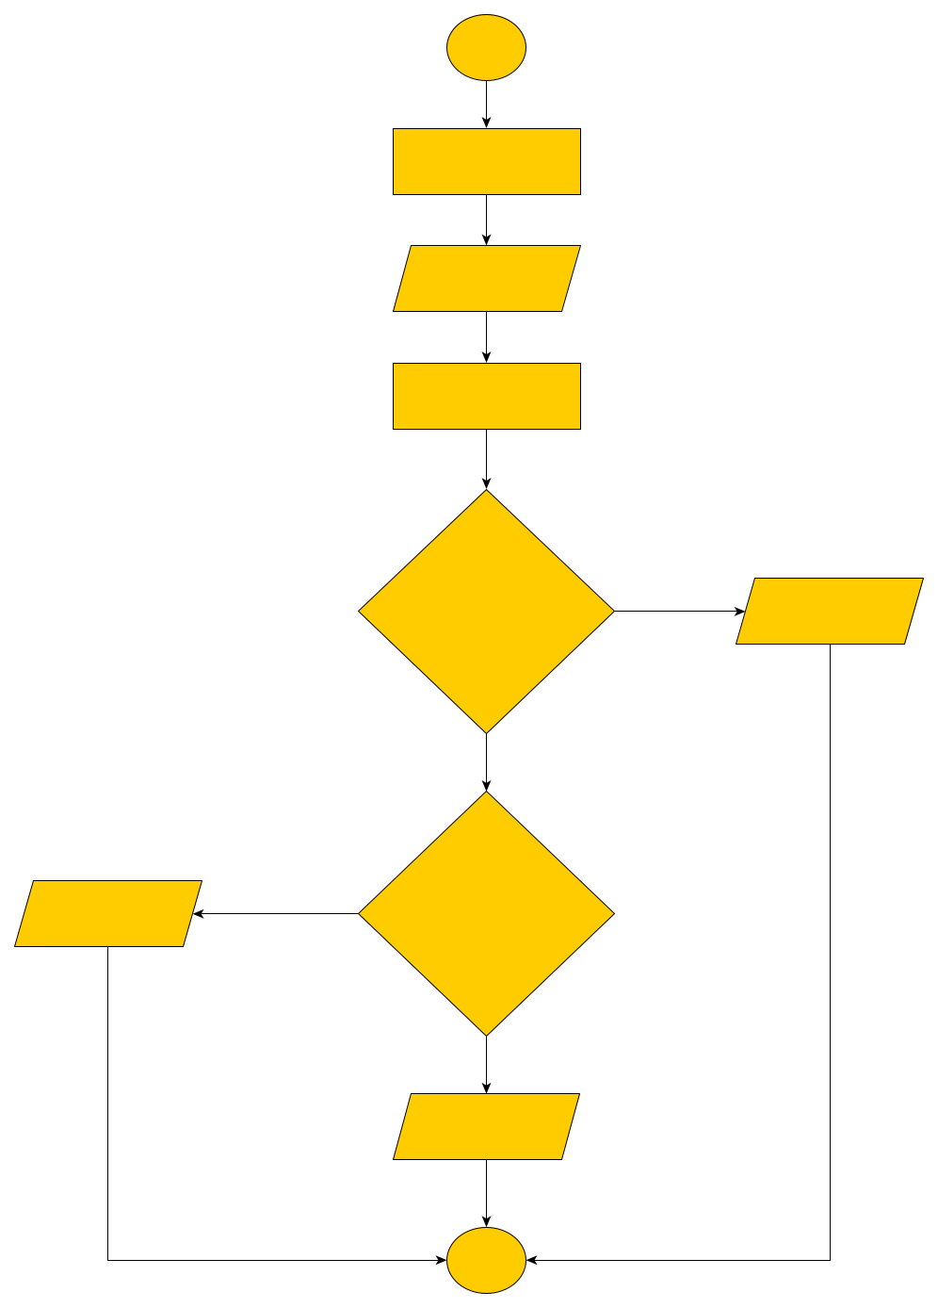

Start

Declare variable

char ch, low

Input ch

low = tolower(ch)

Print “Vowel”

Checking condition of vowel

Checking condition of consonant

Print “Consonant”

Print “Invalid”

Stop

Code –

#include <ctype.h>

int main()

{

char ch,low;

printf("Enter character\n");

scanf("%c", &ch);

low=tolower(ch);

if(low=='a' || low=='e'|| low=='i' || low=='o' || low=='u')

{

printf("Entered character is vowel\n");

}

else if(low>='a' && low<='z')

{

printf("Entered character is consonants\n");

}

else

{

printf("Invalid input");

}

Output –

Enter character

E

Entered character is vowel

10. C Program to check if given year is leap year or not

Algorithm –

Step 1. Start

Step 2. Declare variable int a

Step 3. Inputting the value of a.

Step 4. if(a%100!=0 && a%4==0)

print "It’s a leap year"

else

print "Not a leap year"

Step 5. Stop.

Flowchart –

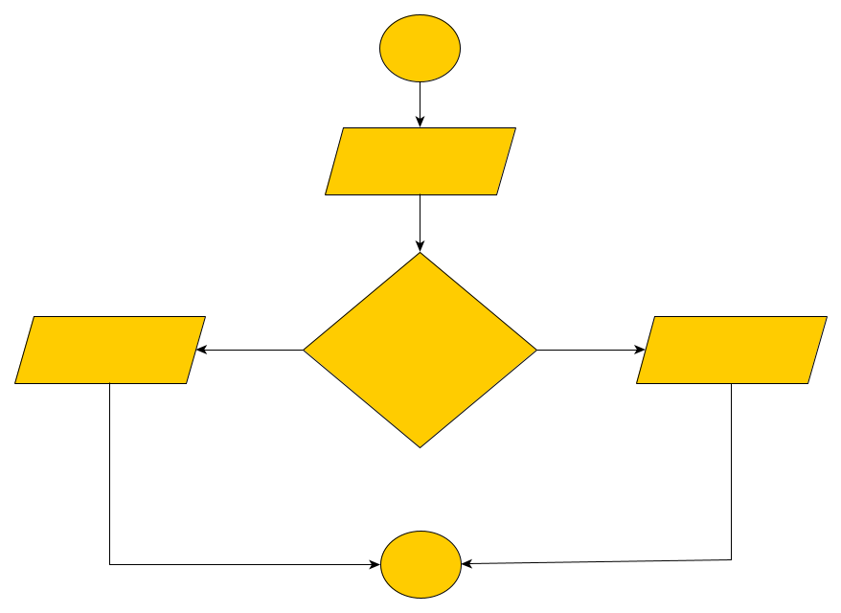

Start

Input a

Checking condition

of leap year

False

True

Print “Not Leap Year”

Print “Leap Year”

Stop

Code –

#include <stdio.h>

int main()

{

int a;

printf("Enter Year\n");

scanf("%d", &a);

if(a%100!=0 && a%4==0)

{

printf("It’s a leap Year\n");

}

else

{

printf("Not a Leap Year\n");

}

}

Output –

Enter Year

2012

Leap Year

11. C Program to check if given character is digit or alphabet

Algorithm –

Step 1. Start.

Step 2. Declare variable ch.

Step 3. Initialize the value of ch.

Step 4. If ch is between 64 and 91 OR ch is between 98 and 123 print “Entered character is alphabet”

Step 5. If ch is between 47 and 58 print “Entered character is digit”

Step 6. else print “Invalid input”

Step 7. Stop.

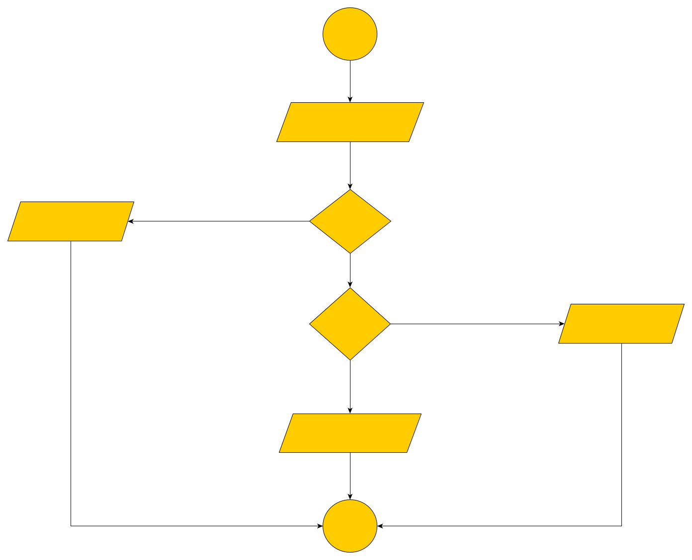Flowchart –

Stop

Print “Invalid”

Print “Digit”

Checking

Digit

Print “Alphabet”

Checking

Alphabet

Input ch

Start

Code –

#include <stdio.h>

int main()

{

char ch;

printf("Enter character\n");

scanf("%c", &ch);

if(ch>64 && ch<91 || ch>98 && ch<123)

{

printf("Entered character is alphabet\n");

}

else if( ch>47 && ch<58)

{

printf("Entered character is digit\n");

}

else

{

printf("Enter Valid input\n");

}

}

Output –

Enter character

u

Entered character is alphabet

12. C Program to convert decimal number to binary number

Algorithm –

Step 1. Start.

Step 2. Declare variable n, rem, bin, temp.

Step 3. Initialize the value of bin=0, temp=1.

Step 4. Inputting the value of n.

Step 5. Using while loop for repeating till n=0.

Finding reminder of n (rem=n%2)

Storing value of reminder in bin.

Step 6. Print the value of bin.

Step 7. Stop.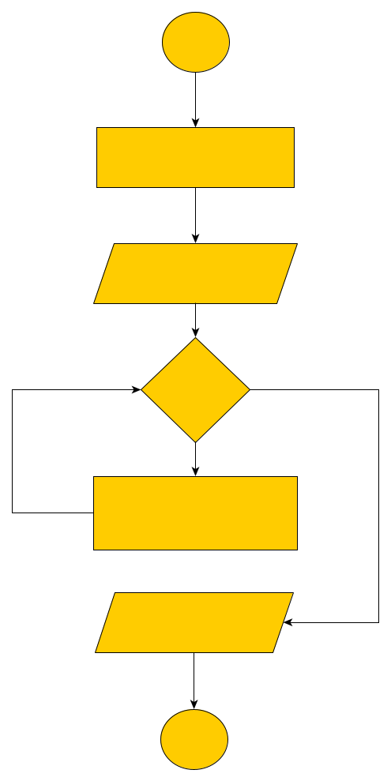

Start

Flowchart –

Declare variable int

n,rem,bin=0,temp=1

Input n

while

(n!=0)

rem=n%2

bin+=rem*temp

temp*=10

Print bin

Stop

Code –

#include <stdio.h>

int main()

{

int n, rem;

int bin=0;

int temp=1;

printf("Enter Number\n");

scanf("%d", &n);

while(n!=0)

{

rem=n%2;

bin=bin+rem*temp;

temp=temp*10;

n=n/2;

}

printf("Binary = %d", bin);

}

Output –

Enter Number

20

Binary = 10100

13. C Program to convert decimal number to hexadecimal number

Algorithm –

Step 1. Start.

Step 2. Declare variable n, rem, sum, i, m.

Step 3. Initialize the value of sum=0, i=1, m[100].

Step 4. Inputting the value of n.

Step 5. Using loop till n=0.

Finding reminder of n (rem=n%16)

If reminder is smaller then 10 then sum store (48 + reminder).

If reminder is greater then 10 then sum store ( 55 + reminder).

Value of sum store in array (m[i++]=sum).

Step 6. Using inverse loop to print the value of array. Print “m[j]”.

Step 7. Stop.

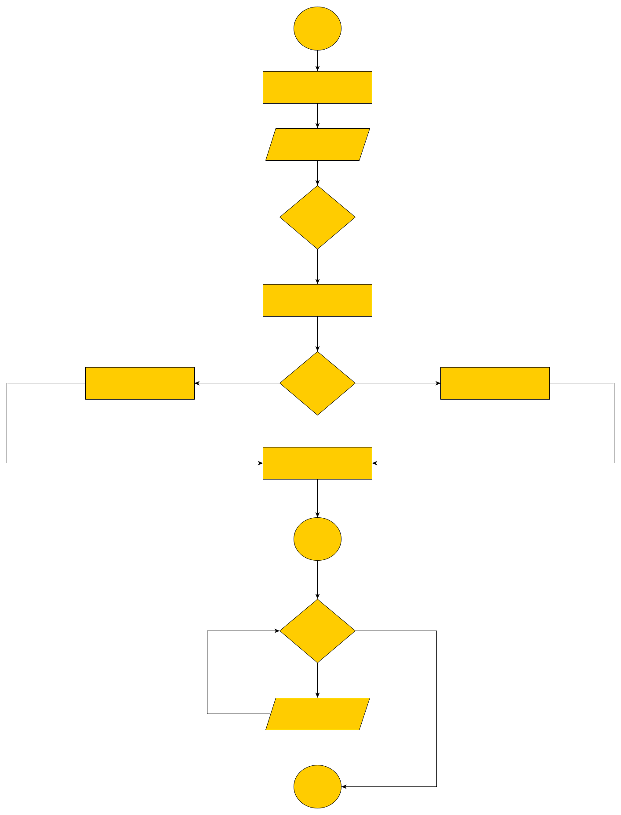Flowchart –

False

True

Loop

closed

Stop

Print m[j]

for(int j=i-1;

j>0; j--)

m[i++]=sum;

n=n/16

sum = 55+rem

sum = 48+rem

if(rem<10)

rem = n%16

while

(n!=0)

Input n

Declare variable int

n,rem,sum=0,i=1 char m[100]

Start

Code –

#include <stdio.h>

int main()

{

int n;

int rem;

int sum=0;

int i=1;

char m[100];

printf("Enter Decimal Number\n");

scanf("%d", &n);

while(n!=0)

{

rem=n%16;

if(rem<10)

{

sum=48+rem;

}

else

{

sum=55+rem;

}

m[i++]=sum;

n=n/16;

}

for(int j=i-1; j>0; j--)

{

printf("%c",m[j]);

}

}

Output –

Enter Decimal Number

180

B4

14. C Program to compute the area and perimeter of a rectangle.

Algorithm –

Step 1. Start.

Step 2. Declare variable area, p, l, b.

Step 3. Inputting the value of l, b.

Step 4. Appling formula of area of rectangle (area=l*b).

Step 5. Appling formula of perimeter of rectangle (per=2*(l+b)).

Step 6. Print the value of area and perimeter.

Step 7. Stop.

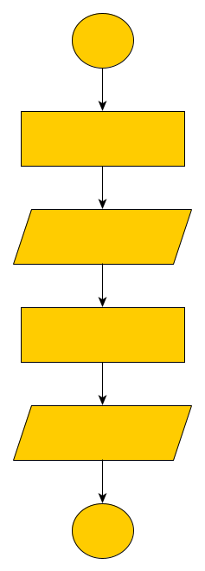Flowchart –

Start

Declare variable int

area, p, l, b

Input l, b

area=l*b

per=2*(l+b)

Print area, p

Stop

Code –

#include <stdio.h>

int main()

{

int area, p;

int l,b;

printf("Enter Length\n");

scanf("%d", &l);

printf("Enter Breadth\n");

scanf("%d", &b);

area=l*b;

p=2*(l+b);

printf("Area=%d",area);

printf("\nPerimeter=%d",p);

}

Output –

Enter Length

10

Enter Breadth

7

Area=70

Perimeter=34

15. C Program to convert decimal number to octal number.

Algorithm –

Step 1. Start.

Step 2. Declare variable n, rem, rev, i, m, temp.

Step 3. Initialize the value of rev=0, temp=1, i=1, m[100].

Step 4. Inputting the value of n.

Step 5. Using loop till n=0.

Finding reminder of n (rem=n%8)

Value of reminder store in array (m[i++]=rem).

Step 6. Using inverse loop to print the value of array. Print “m[j]”.

Step 7. Stop.

Flow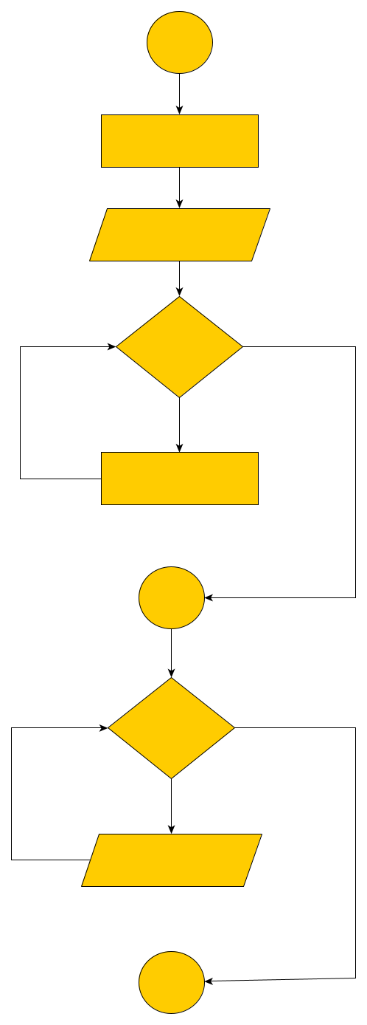chart –

Stop

Print m[j]

for(int j=i-1;

j>0; j--)

Loop

closed

rem=n%8

m[i++]=rem

n=n/8

Declare variable int

n,rem,rev=0,i=1, temp=1

char m[100]

Input n

while

(n!=0)

Start

Code –

#include <stdio.h>

int main()

{

int n,rem;

int rev=0, temp=1;

int i=1;

int m[100];

printf("Enter Decimal Number\n");

scanf("%d",&n);

while(n!=0)

{

rem=n%8;

m[i++]=rem;

n=n/8;

}

for(int j=i-1; j>0; j--)

{

printf("Octal is =%d", m[j]);

}

}

Output –

Enter Decimal Number

200

Octal is = 310

16. C Program to convert binary number to decimal number

Algorithm –

Step 1. Start.

Step 2. Declare variable n, rem, sum, temp.

Step 3. Initialize the value of sum=0, temp=1.

Step 4. Inputting the value of n.

Step 5. Using while loop for repeating till n=0.

Finding reminder of n (rem=n%2)

Storing value of reminder in sum.

Step 6. Print the value of sum.

Step 7. Stop.

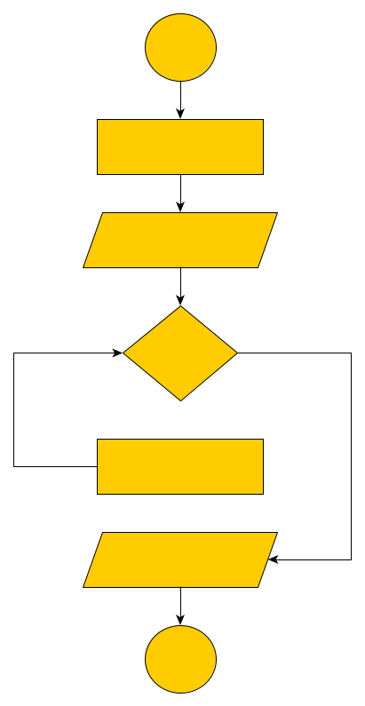Flowchart –

Start

Declare variable int

n,rem,sum=0,i=1, temp=1

Input n

while

(n!=0)

rem=n%10

sum+=sum*temp

temp*=2

Print sum

Stop

Code –

#include <stdio.h>

int main()

{

int n,rem,sum=0,temp=1;

printf("Enter Number\n");

scanf("%d", &n);

while(n!=0)

{

rem=n%10;

sum=sum+rem*temp;

temp=temp*2;

n=n/10;

}

printf("Decimal is = %d", sum);

}

Output –

Enter Number

101010

Decimal is = 42

17. C Program to convert hexadecimal number to decimal number

Algorithm –

Step 1. Start.

Step 2. Declare variable hex, sum, i, len, total.

Step 3. Initialize the value of total=0, i=1, hex[15].

Step 4. Inputting the value of hex.

Step 5. Storing the length of hex.

Step 6. Using for loop till hex[i]=‘0’.

If hex[i] greater then equal to ‘0’ and hex[i] smaller then equal to ‘9’ then sum = hex[i] – 48.

If hex[i] greater then equal to ‘a’ and hex[i] smaller then equal to ‘f’ then sum = hex[i] – 97 +10.

If hex[i] greater then equal to ‘A’ and hex[i] smaller then equal to ‘F’ then sum = hex[i] – 65 +10.

Total store the value of sum by multiply power 16 (total=total + sum*pow(16, len)).

Step 6. Print the value of total.

Step 7. Stop.

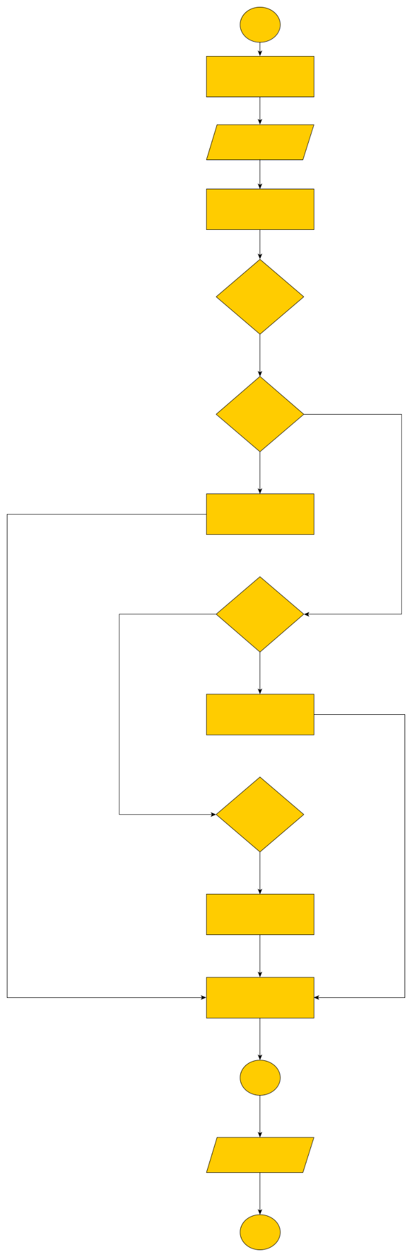Flowchart –

Stop

Print total

Loop

closed

Condition

hex[i]>=’A’

hex[i]<=’F’

Condition

hex[i]>=’a’

hex[i]<=’f’

total+=sum*pow(16, len)

len--

sum = hex[i] – 65+10

sum = hex[i] – 97+10

sum = hex[i] - 48

Condition

hex[i]>=’0’

hex[i]<=’9’

for(i=0;

hex[i]!='0'; i++)

len=strlen(hex)

Input hex

sum,len,total=0,i=0

char hex[15]

Start

Code –

#include <stdio.h>

#include <math.h>

#include <string.h>

int main()

{

char hex[15];

int i=0;

int sum,len;

int total=0;

printf("Enter Hexa\n");

gets(hex);

len=strlen(hex);

len--;

for(i=0; hex[i]!='0'; i++)

{

if(hex[i]>='0' && hex[i]<='9')

{

sum = hex[i] - 48;

}

else if(hex[i]>='a' && hex[i]<='f')

{

sum = hex[i] - 97 + 10;

}

else if(hex[i]>='A' && hex[i]<='F')

{

sum = hex[i] - 65 + 10;

}

total= total+ sum * pow(16, len);

len--;

}

printf("Decimal Num=%d", total);

}

Output –

Enter Hexa

D6

Decimal Num=214

18. C Program to convert octal number to decimal number

Algorithm –

Step 1. Start.

Step 2. Declare variable n, rem, rev, temp.

Step 3. Initialize the value of rev=0, temp=1.

Step 4. Inputting the value of n.

Step 5. Using while loop for repeating till n=0.

Finding reminder of n (rem=n%10).

Storing value of reminder in rev.

Step 6. Print the value of rev.

Step 7. Stop.

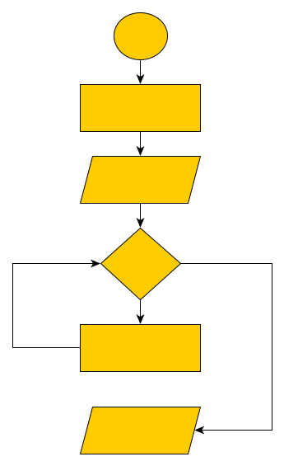

Flowchart –

Start

Declare variable int

n,rem,rev=0,temp=1

Input n

while

(n!=0)

rem=n%10

sum+=sum*temp

temp*=8

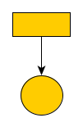

Read rev

Stop

Code –

#include <stdio.h>

int main()

{

int n, rem;

int rev=0, temp=1;

printf("Enter Numer\n");

scanf("%d", &n);

while(n!=0)

{

rem=n%10;

rev=rev+rem*temp;

temp=temp*8;

n=n/10;

}

printf("Decimal=%d", rev);

}

Output –

Enter Numer

167

Decimal=119

19. C Program to generate multiplication table

Algorithm –

Step 1. Start.

Step 2. Declare variable n, sum.

Step 3. Inputting the value of n.

Step 4. Using while loop for repeating till i<=10.

Sum storing the multiplication of n and i (sum=i*n).

Print the value of sum.

Step 5. Stop.

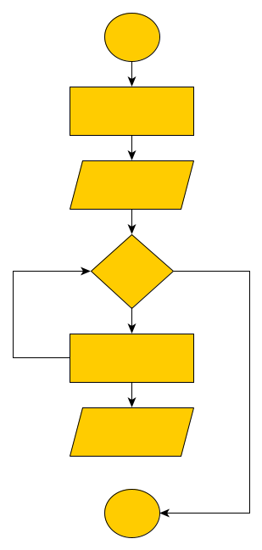Flowchart –

Start

Declare variable int

n, sum

Input n

**for(int i=1;**

**i<=10; i++)**

sum=i*n

Print sum

Stop

Code –

#include <stdio.h>

int main()

{

int n, sum;

printf("Enter Number\n");

scanf("%d", &n);

for(int i=1; i<=10; i++)

{

sum=i*n;

printf("\n%d", sum);

}

}

Output –

Enter Number

8

8

16

24

32

40

48

56

64

72

80

20. C Program to print fibonacci series.

Algorithm –

Step 1. Start.

Step 2. Declare variable a, b, c.

Step 3. Inputting the value of a=0, b=1, c=0.

Step 4. Using while loop for repeating till i<8.

c storing the addition of a and b (c=a+b).

Print the value of c.

Changing the value of a into b then b into c.

Step 5. Stop.

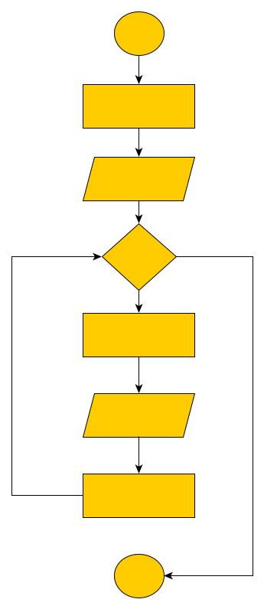Flowchart –

Start

Declare variable int a=0, b=1, c=0, n

Input n

for(int i=0;

i<10; i++)

c=a+b

Print c

a=b

b=c

Stop

Code –

#include <stdio.h>

int main()

{

int a=0, b=1, c=0;

int n;

printf(“Enter length of series”);

scanf(“%d”, &n);

for(int i=0; i<n; i++)

{

c=a+b;

printf("\n%d", c);

a=b;

b=c;

}

}

Output –

1

2

3

5

8

13

21

34